Televangelist Todd Coontz Indicted on Tax Fraud, Claims $1.5M Condo, Ferraris Are Business Expenses
BY STOYAN ZAIMOV , CHRISTIAN POST REPORTER
Jun 27, 2017 | 7:47 AM
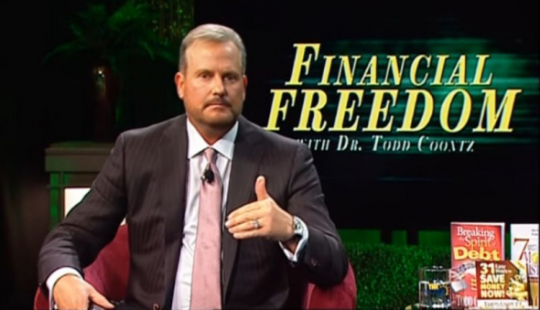
Todd Coontz appearing on his "Financial Freedom" show in November 11, 2016.
After North Carolina televangelist Todd Coontz was indicted on tax fraud charges last week, claiming that his $1.5 million condo and luxury cars were "business expenses," a group that monitors ecclesiastical fraud has warned that some preachers are "raping" the Christian community.
"It's time the IRS started looking into these people that are raping the Christian community," Trinity Foundation President Ole Anthony told The Christian Post in a phone interview on Monday.
Anthony, whose Texas-based group reports on fraud committed by pastors and televangelists, said people who scheme others out of their money are not leading Christian lives.
"They are cheating the people of knowing the mystery of God," he said.
As The Charlotte Observer reported last week, Coontz was indicted on three counts of failure to pay taxes and four counts of aiding and assisting in the filing of false tax returns.
The televangelist and author of several books on the topic of seed giving that he says can make people rich, claimed as business expenses his family's $1.5 million condo, along with a fleet of luxury cars, including three BMWs, two Ferraris, a Maserati and a Land Rover.
The federal criminal bill of indictment further states that Coonz provided no proof that his Regal 2500 boat, 400 charges at movie theaters, $228,000 in clothing purchases and $140,000 in meals and other entertainment were all business expenses.
U.S. Attorney Jill Rose said when announcing the charges: "This is a classic example of 'Do as I say, not as I do.'"
"As a minister, Coontz preached about receiving and managing wealth, yet he failed to keep his own finances in order. Coontz will now receive a first-hand lesson in 'rendering unto Caesar' that which is due," Rose added.
Coontz, who was the minister of Rock Wealth International Ministries from 2010 to 2014, says on his website that others describe him as a "pastor, evangelist, television host, author, humanitarian, philanthropist, businessman."
His lawyer, Mark Foster of Charlotte, said in a statement that Coontz "unequivocally asserts his innocence ... and will vigorously defend himself against these charges."
"Todd Coontz has always endeavored to follow the law and to be a good citizen, father, and minister. He trusted others to manage his finances and taxes for him and was shocked to find out he was under criminal investigation by the IRS," Foster said, outlining his expectation that the jury will find his client not guilty after hearing the evidence.
Anthony told CP, however, that he's "very thankful that the IRS finally took some action," both on Coontz and on televangelist Benny Hinn.
Hinn, who has asked his supporters in the past to step up to "higher seed-level giving" by donating $1,000 to his ministry, basing his request on Coontz's financial teachings, admitted back in April that criminal investigators from the IRS and inspectors from the U.S. Postal Service had raided his offices in Grapevine, Texas.
Hinn said he's "cooperating fully with the governmental entities" who are "reviewing certain operations of the Church," but did not provide further details.
Anthony added that televangelists such as Hinn and Coontz like to "give each other credit," and build their own ego.
"There is more fraud committed in the name of God than any other fraud in the world," he said.
"We just found out that there's now more clerical fraud, ecclesiastical fraud than there is money given for missions. And now, this year, it's in the neighborhood of $55 billion for fraud, and about $49 billion for missions," he explained.
"They are not feeding the hungry or clothing the naked or housing the homeless, they are building themselves mansions and multiple jet planes," he said of televangelists who commit fraud.
"It's heresy that's worse than almost any heresy that I know of," the Trinity Foundation president continued. "Jesus warned of it. The only time I'm aware that He said He hated something [was] the doctrine of Balaam and the doctrine of Nicolaitans in the book of Revelation."
Anthony noted that while the doctrine of Balaam talks about mixing religion with politics and money; the doctrine of Nicolaitans preaches success in the world in the name of God.
"There's no End Times revival — it's an End Times apostasy, and we're now seeing the greatest apostasy that the world has ever known," he positioned.
The Trinity Foundation, he said, has submitted 38 reports to the Senate Finance Committee on abuses to the tax code and on ecclesiastical fraud that is being committed.
Anthony said that while the committee promised that there would be hearings, at the end nothing was done. He claimed that many politicians are afraid of those in the Christian community who preach "the success theology."
"They hire the nation's best attorneys, and ex-IRS directors," he said of fraud suspects.
"It just infuriated me," he said of the committee's inaction.
The Trinity Foundation also sent CP Anthony's unpublished comments in an interview with WSOC-TV Charlotte four years ago when when Coontz asked views to send him a $273 'Recovery Seed' donation to experience a "supernatural change in 90 days." The number 273 is also the number to his $1.5 million condo.
"There are many thousands that are victims that are giving their money under false pretenses, false promises. It's a sham. In any other society it would be criminal. But in religious broadcasting it's the soup du jour.
"There is no accountability for the ministers. They get by with anything they want to do because prosecutors and law enforcement agencies in this country do not want to go after religious figures," Anthony said.

